Introduction

This is the documentation for Project 4 of the Udacity VR Nanodegree. In this project, I used the process of planning, iteration and user testing to create a VR experience. This VR Experience is presented as a “Simon Says” style puzzle game.

Outcome: Puzzler Game

The setting of the puzzle is a Medieval Dungeon. The player enters a scary and dark dungeon and must complete the puzzle to exit.

The Process

Statement of Purpose:

Persona:

Sketches:

|  |  |
| --- | --- |
| The Dungeon Scene  https://cdn-enterprise.discourse.org/udacity/uploads/default/optimized/3X/2/f/2f91dbb19dca13d6c99807daf40d77628873699b_1_375x500.JPG | The UI |

User Testing Outcomes and Iteration

User Testing 1: The basic scene

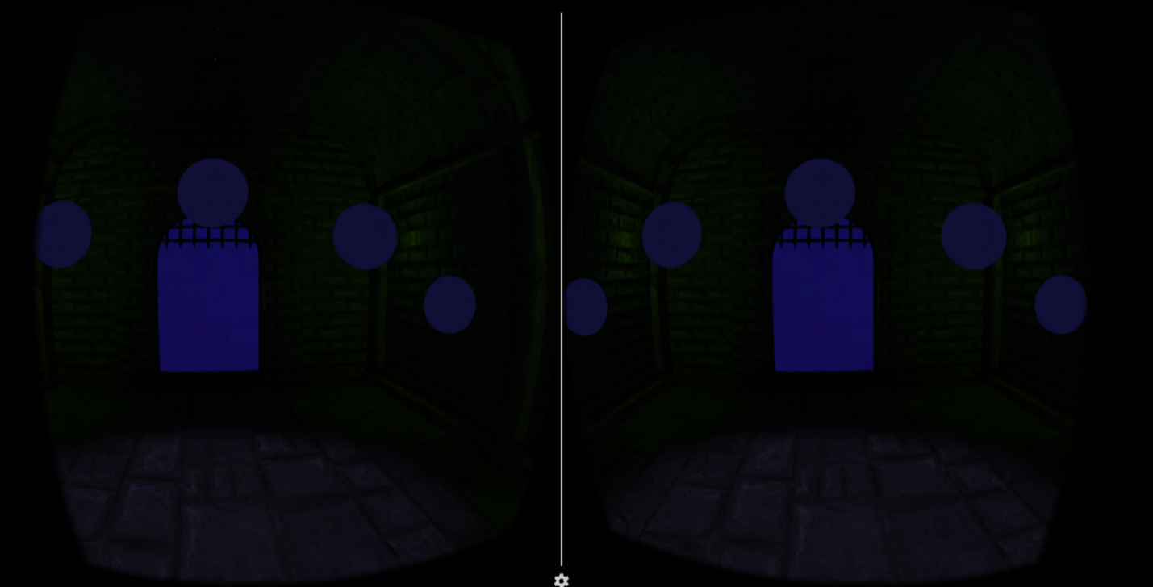

Users Tested: Santiago D. L. and May H. (both are work peers)

Questions:

1. How big do you feel in the scene?
2. What is the mood or the ambiance of the scene?
3. Is there anything that is difficult to see?

Results:

|  |  |  |  |
| --- | --- | --- | --- |
| User | Q1: How big do you feel? | Q2: What is the mood or ambiance of the scene? | Q3: Is there anything that is difficult to see? |
| Santiago | Feels very big. Like the door might hit his head. | Looks like a dungeon. It is very narrow. | Nothing. |
| May | Feels alright. | Feels like in a castle room. Very dark. | No, but can see a bothering line for the separation of the two halves of the roof. |

Adjustments made from the results:

1. Decided to keep the size, to make the user feel a little claustrophobic. I believe the scale is OK, but moved the camera a little down and closer to the door so as to make the users feel comfortable.
2. Fixed the annoying line on the roof.
3. Made the lights brighter.

User Testing 2: The UI Elements

Users Tested: Santiago D. L. and Alexandra S. (my wife)

Questions:

1. Is the position of the UI elements ok?
2. Can you read what it says on the screens?
3. Does the text make sense and can you follow along?

Results:

|  |  |  |  |
| --- | --- | --- | --- |
|  | Q1: Is the position of the UI elements ok? | Q2: Can you read what it says on the screens? | Q3: Does the text make sense and can you follow along? |
| Santiago | Feels too close. Also, very large. | Yes. | Yes, but what is it for? |
| Alexandra | Feels very close. Somewhat disturbed by it. | Yes but not comfortable due to size and closeness. | Yes. |

Adjustments made from the results:

1. Moved the UI Canvases further from the user, so as to not invade their space. This in return made it look smaller.
2. Modified the text so they knew to press the button to start to play.

User Testing 3: The Final Game

Users Tested: Santiago D. L., Alexandra S., Suhel T. (brother), Fadi T. (brother)

Questions:

1. How was your experience?
2. Did you like the scene?
3. Was the puzzle difficult to solve?
4. What could be improved about the experience?

Results:

|  |  |  |  |  |
| --- | --- | --- | --- | --- |
|  | Q1: How was your experience? | Q2: Did you like the scene? | Q3: Was the puzzle difficult to solve? | Q4: What could be improved about the experience? |
| Santiago | Interesting. Challenging. | Still feel it is a little narrow, but the scene is good. Had a hard time seeing the orbs. | Yes. Did not understand what was going on. Took about 5 tries to get it. | Better instructions. Make orbs easier to see. |
| Alexandra | Enjoyed it. Neat experience. | Yes, but feels very empty and not too scary for a dungeon. | No, took 2 tries but I had to explain what to do. They didn’t know how to proceed. | Better instructions and make room scarier. |
| Suhel | Hated it. Got dizzy. Could not look at project for more than 10 seconds. | No comment. Not enough time spent with it to take a good look. | Quit using the app before they had time to play. | User was to dizzy to continue and did not want to try again. Suggest investigating how to make it a more pleasant experience. |
| Fadi | Thought it was cool. | It is a dungeon. Asked what the orbs were for. | Took 3 tries. Had no idea what was going on. | No comment. They thought it was cool as it is. |

Adjustments made from the results:

1. Modified the instructions in the first UI canvas so the player had a better idea of what to do.
2. Changed the orbs colors so they were better to see. I had changed them to a red color before. Reverted to a blueish color and made the hover material brighter.
3. Added some skeletons so that the room felt less empty and scarier.
4. Modified the movement speed so as to not make the user very dizzy.

Breakdown of Final Piece

Conclusion

Next Steps